ELE410/416/468: Project and Dissertation – Aim and Objectives
Student name: Ethan Anthony Pratt
Student Reg No: 250217092
MEng or BEng: MSc
Project Title: Monte Carlo modelling of X-ray generation and detection in energy-dispersive X-ray spectroscopy (EDXS) of GaAsBi alloys in a transmission electron microscope (TEM)
Supervisor: Dr. Thomas Walther
Second Reader: To be allocated

Project Aim:

To develop a Monte-Carlo simulation framework that models X-ray generation, signal attenuation, and detection in GaAs_{1-x}Bi_{x} thin foils under STEM-EDXS conditions, with the ultimate goal of identifying the optimal X-ray line pairs and geometric parameters for the accurate quantitative analysis of bismuth concentration.

Project Objectives, to be described as:
Basic Objectives:
LO1: Material Rationale: Analyse the impact of bismuth content and lattice strain on the GaAs_{1-x}Bi_{x} compound and the physics of band-gap bowing for optoelectronic value.

The rationale for use for IR optoelectronics is that incorporating heavy Bi atoms reduces the band-gap as well as the temperature dependence of the band-gap. Strain is rather considered an unwanted side effect.

﻿﻿LO2: Geometric Constraints: Use Monte-Carlo simulations for free-standing thin foil specimen geometry for energy-dispersive X-ray spectroscopy (EDXS) in a 200kV scanning transmission electron microscope (STEM) with a fixed 25° take-off angle of the X-ray detector and no substrate to determine the impact on X-ray absorption and escape paths.

Advanced Objectives:
﻿﻿LO3: Signal Attenuation: Investigate the dependency of X-ray generation and absorption on foil thickness and density (Bi content), specifically focusing on the absorption of bismuth K, L, and M lines relative to either gallium K or L or arsenic K or L as reference

﻿﻿LO4: Parameter Sweep: Implement a Python-based sweep (200keV, 10e6 electron trajectories), varying thickness across a geometric doubling series of ten values from 2 nm to 1024 nm (2, 4, 8, 16, 32, 64, 128, 256, 512, 1024 nm) and Bi-concentration (x=0.01-0.2) to determine the most reliable X-ray line pair for quantification

My project requires components/items to be purchased and I confirm that I have completed the budget request form on Blackboard (please answer yes/no in the box on the right) | No
Will (or do you anticipate) that any part of your project will require ethics approval? – (please check with your supervisor and answer yes/no in the box on the right) | No
Will (or do you anticipate) that any part of your project will be confidential? – (please check with your supervisor and answer yes/no in the box on the right) | No
Does that project involve practical components that will require a health and safety assessment before commencing work? – (please check with your supervisor and answer yes/no in the box on the right) | No
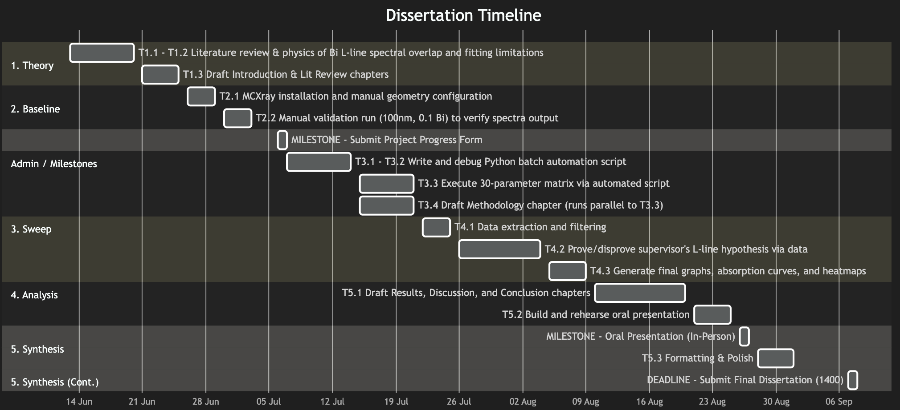
Student name (Print): Ethan Anthony Pratt Date: 18/05/2026

